LAWRENCE NATURE CENTER
481 Drexel Avenue – Lawrence Township, NJ 08648
www.lawrencenaturecenter.com – lawrenenaturecenter@gmai.com

Keeping an Eye on Nature

HOLIDAY DECORATING WORKSHOP
REGISTRATION FORM
Sponsored by the Friend of the Lawrence Nature Center (FLNC)

Date: Wednesday, December 5th, 2018
Time: 7:00 pm
Location: Lawrence Nature Center – The Rink House – 481 Drexel Ave, Lawrence Twp., NJ 08648

NAME: _____________________________________________________________________

PHONE ____________________________________________________________________

EMAIL:____________________________________________________________________

ADDRESS: ________________________________CITY:___________________________

STATE: ______ZIP: _________

Print Name:________________ Signature:_______________________Date:_______

(Additional questions? Contact: Teresita Bastides-Heron (LNC) at lawrencenaturecenter@gmail.com, or terebh1812@gmail.com, or leave a message at 609.882.6367). Give your name and phone number and we will get back to you as soon as possible. Makes check for $35.00 payable to theLawrence Nature Center and mail it to the address listed below.

COMPLETE YOUR REGISTRATION BY DECEMBER 1ST, 2018.

PLEASE FILL OUT ALL REQUESTED INFORMTION AND SEND TO:

LAWRENCE NATURE CENTER
C/o TERESITA BASTIDES-HERON
78 MERILINE AVENUE
LAWRENCE TWP., NJ 08648

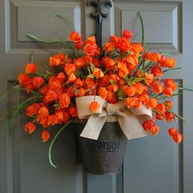

KEEPING AN EYE ON NATURE

